AWS Networking

 Lets create a vpc (192.168.0.0/16)

 Every AWS Region has a default vpc  Every vpc has a default route table

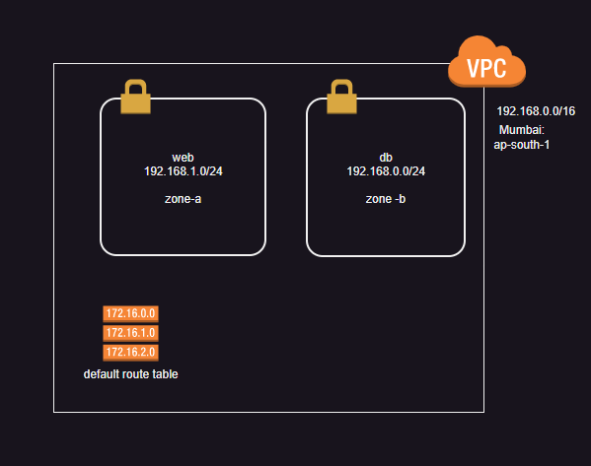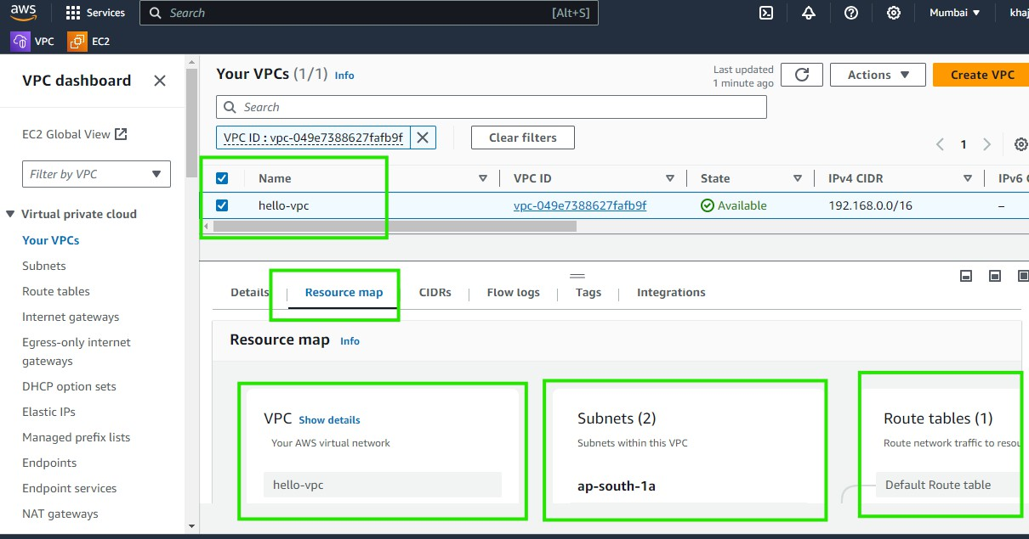 Lets create two subnets as shown below

Create a security group with every thing opened

Lets create an ec2 instance with public ip in web subnet

try connecting and it will not work as our vpc doesnot have internet gateway Now create an internet gateway attach to the vpc

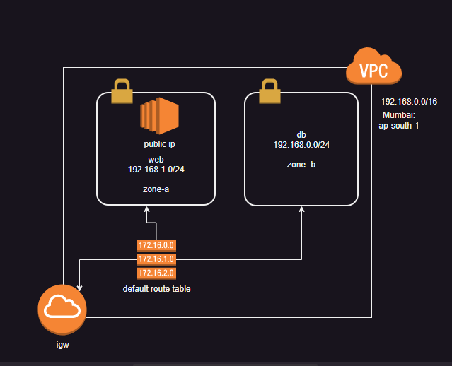Change the default route table routes to forward the traffic to internet gateway (0.0.0.0/0)

Rules

Lets create a new route table and call it as public route table  It will have route to internet gateway

Lets create a new route table anc all it as private route table  It will not have a route to internet gateway

Lets associate web subnet to public route table

Routers and firewalls or other network devices use cidr range to filter and express ips allowed or disallowed. In this only network id is considered

 192.168.0.0/16 => 192.168.x.x => any ip from 192.168.0.0 to 192.168.255.255

 192.168.0.11/32 => 192.168.0.11

 0.0.0.0/0 => x.x.x.x => 0.0.0.0 to 255.255.255.255

Note: Refer classroom video for screen shots